The following instructions are prepared using MobaXterm (a free software).

Any tools that provide SSH and X11 forwarding should also work. However, we recommend using MobaXterm.

If you are using a Mac laptop, we suggest utilizing the computer in Lab ECSS 2.104A,

as it is equipped with MobaXterm.

# Use MobaXterm to connect to the server

Download and install [MobaXterm](https://mobaxterm.mobatek.net/download.html).

Run MobaXterm and create a new session.

Choose SSH for the session type.

Put ***xsudsu.utdallas.edu*** in ***Remote host***.

Put your ***NetID*** in ***Specify username***.

Check ***X11-Forwarding*** setting.

Click ***OK*** and double click that session you just created.

Enter Your UTD password.

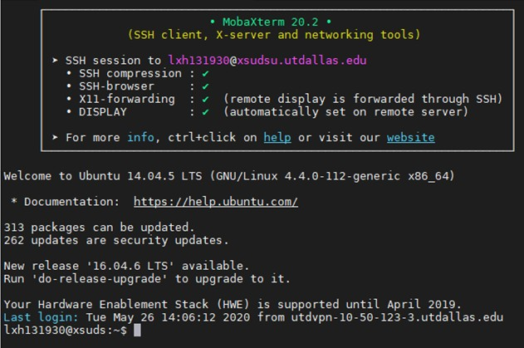

You should be able to log in as the above.

Then, type “ssh -X %yourNetId%@192.168.0.14”

Replace “%yourNetId%” with your NetId.

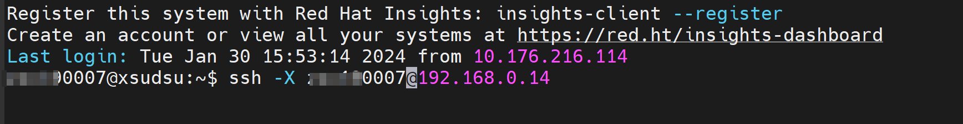

Hit enter, the system will request the password.

Enter the initial password: “changepasswd” to access the project server.

Once you access the project server successfully,

run “ls”, you should be able to see the Project-1 folder under your directory.

